Aleteia

What to do and not do when picking a Confirmation saint
Katrina Fernandez | Oct 11, 2016

Keep in mind: You don't pick the saint, the saint picks you. But you still need to prepare...
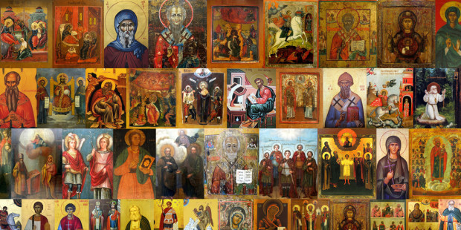

Dear Katrina,
I’ll be getting confirmed soon and I wondered how to pick a Confirmation saint. How did you pick yours? I asked my parents and my dad doesn’t remember and my mom said she just picked her saint because she had the same name as her. I obviously can’t do what my mom did because there is no St. Raeghan.
My Confirmation teacher said the saint we pick is the one that will be our patron the rest of our lives and to pick a good one that we like. There are so many good ones, how do I choose?
Raeghan

Dear Raeghan,
My son is probably close to your age and going through the same thing. Like you, he has no idea whom to choose. I’m a convert so I got to pick my saint as an adult, which made things a bit easier. You’re right, your patron saint is for life but it doesn’t mean the one saint you pick now is the only one you’ll ever learn to love.
Try not to think of it as such a final decision because the saints will come and go throughout your entire life. A saint may come to you at one phase in your life because you need their intercession, but then later on another saint may come to you. In the course of a decade I’ve become acquainted with St. Anthony of Padua, St. John Bosco, St. Monica, and St. Joseph. Each saint played an important patron-like role during very specific times in my life when I needed them most. You’ll find that same will apply to you as well.
My patron saint, Mary Magdalene, is always at the ready for me but that doesn’t close me off from developing fondness and connections to the rest of the Church Triumphant. The saints in heaven, after all, are part of the same family.
I’ll give you the same advice I got when I was picking my confirmation saint… you don’t choose the saint, the saint chooses you.
In the course of making your decision you’ll no doubt be asked to read material on the lives of various saints. Keep a list from your studies of saints you like and feel an affinity for. You can also pick saints from regions that your ancestors are from. Add to that list the names of people in your family who are particularly close to you or names that have some personal meaning to you. Then check and see if that name has a saint associated with it. There is no St. Katrina but there were plenty of Katherines for me to choose from. Raeghan is an unusual name but perhaps it has origins you can research. Or maybe you’re supposed to be the first Saint Raeghan!
Once you’ve made your list of saints ask each one to pray for you as you make this decision. You may find the list shorten or grow as you go through the process. That’s OK. Take your list to adoration and make an effort to pray about it daily.
Eventually the choice will be made known to you if you put in the deliberate effort. That’s the key though, making the deliberate effort. If you just pick a random name at the very last minute you could be cheating yourself out a strong intercessory advocate in heaven.
Mary Magdalene came to me after presenting herself over and over in prayer, readings, and conversations. Her name just kept popping up. She decided it was settled, not me. My last bit of advice would be for you to keep your ears, eyes, and heart open so you can be receptive for your saint’s calling.

